ISCG 7420 Assignment 1 Documentation

Aquila Halpé 2017

(unable to publish to DocHyper, unable to submit to Moodle. Please see <https://github.com/VDCuddles/WADAssignment1> for full solution, thank you)

Business Specification

The project will involve developing a simple web application (a simple online purchase order system) for Quality Bags, which is a fictional company selling bags. There are two classes of users, a customer user and an administrator user. The application allows an administrator to create records for bag categories, create records for bags and submit bags under a bag category. An administrator can also manage customer orders. A customer can view all the available bag categories and the bags within a category. A customer doesn’t need an account to view the bags. However, a customer must have a shopping account to order a bag. An administrator needs to use an existing account to login. An administrator can disable a customer shopping account. The Quality Bags website contains at least two areas: a catalogue area and a shopping cart area. A customer can browse the catalogue, place bags in the shopping cart, and then place an order. The customers click add to cart button to add a selected bag to the cart, click a checkout button to place the order and click a login button to authenticate entry into the shopping account. If the customer hasn’t registered yet, let the customer register before login. A customer can click a clear button to empty the shopping cart. Each order item in the shopping cart should include the bag item ID, the bag name, the quantity, the price and the total cost. Adding the same order item twice will increase the quantity of that order item by one. The shopping cart should also include a subtotal, a GST(15%) and a grand total. We assume that each type of the bags has sufficient stock for ordering. The application must maintain all the submitted bag categories and the required information for each bag within the database. This includes the bag ID, the name, the supplier, the category, the price, the description and an image of the bag. One bag item has only one supplier and one supplier may supply more than one bag item. The examples for a bag category are Men’s Bags, Women’s Bags and Children’s Bags. The information for a supplier should include the supplier ID, the name, the contact phone number (home, work and mobile, only one is compulsory) and the email address. The information for a customer should include the customer ID, the name, the contact phone number (home, work and mobile, only one is compulsory), the email address and the address. A customer order should include a list of order items, the customer ID, the subtotal, the GST(15%) and the grand total. The developer will need to decide what information should be saved into the database for an order item.

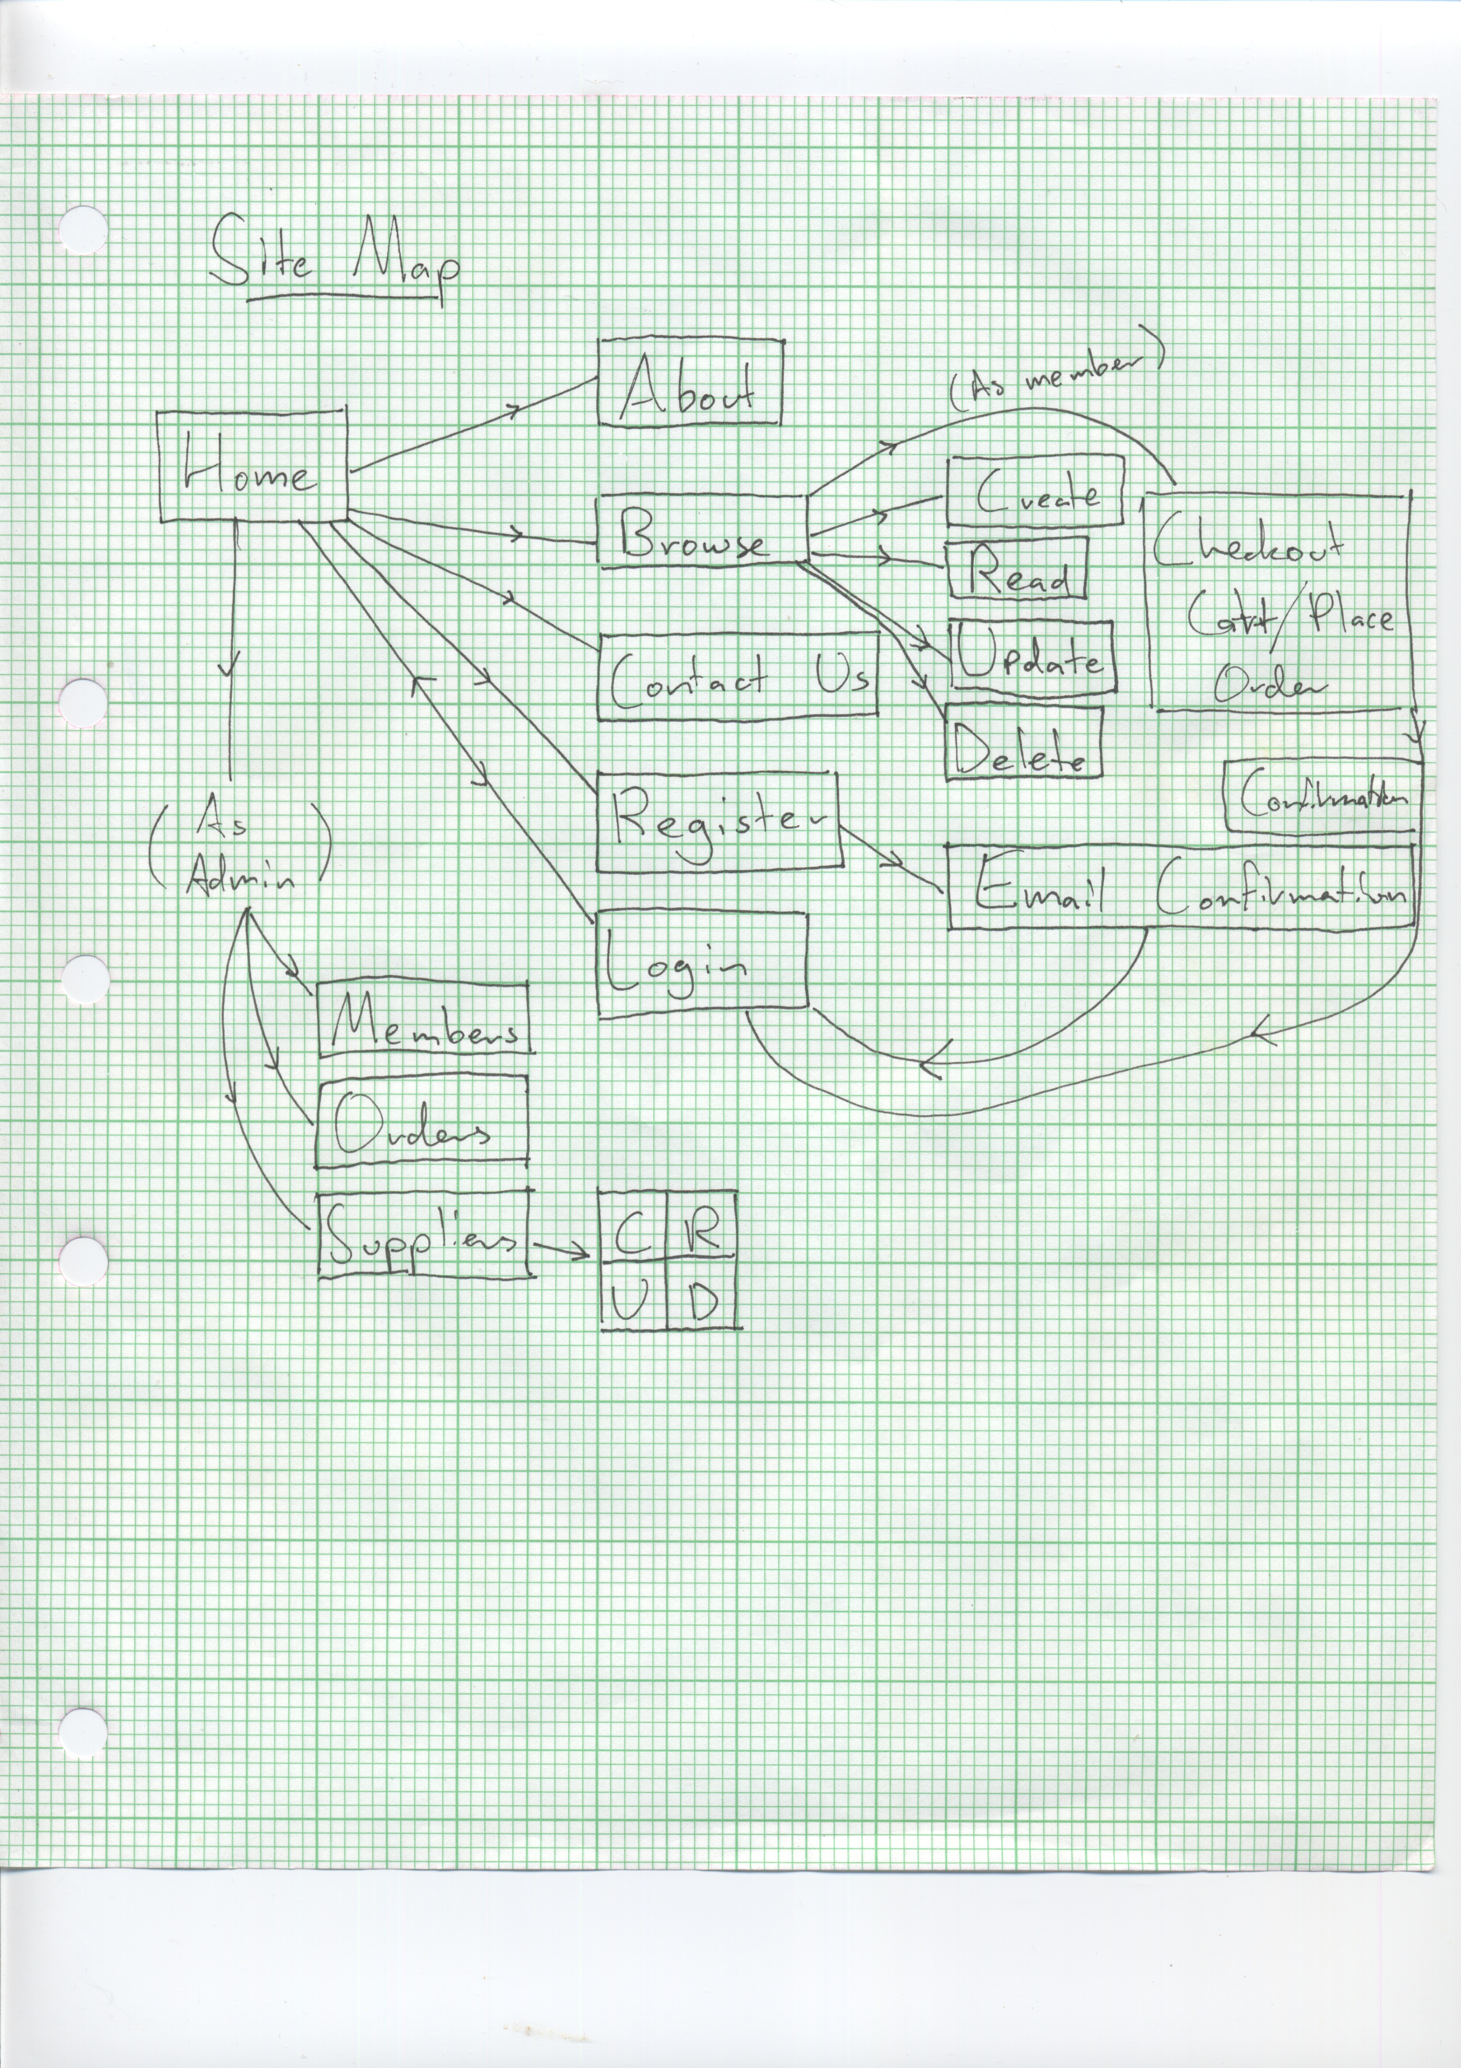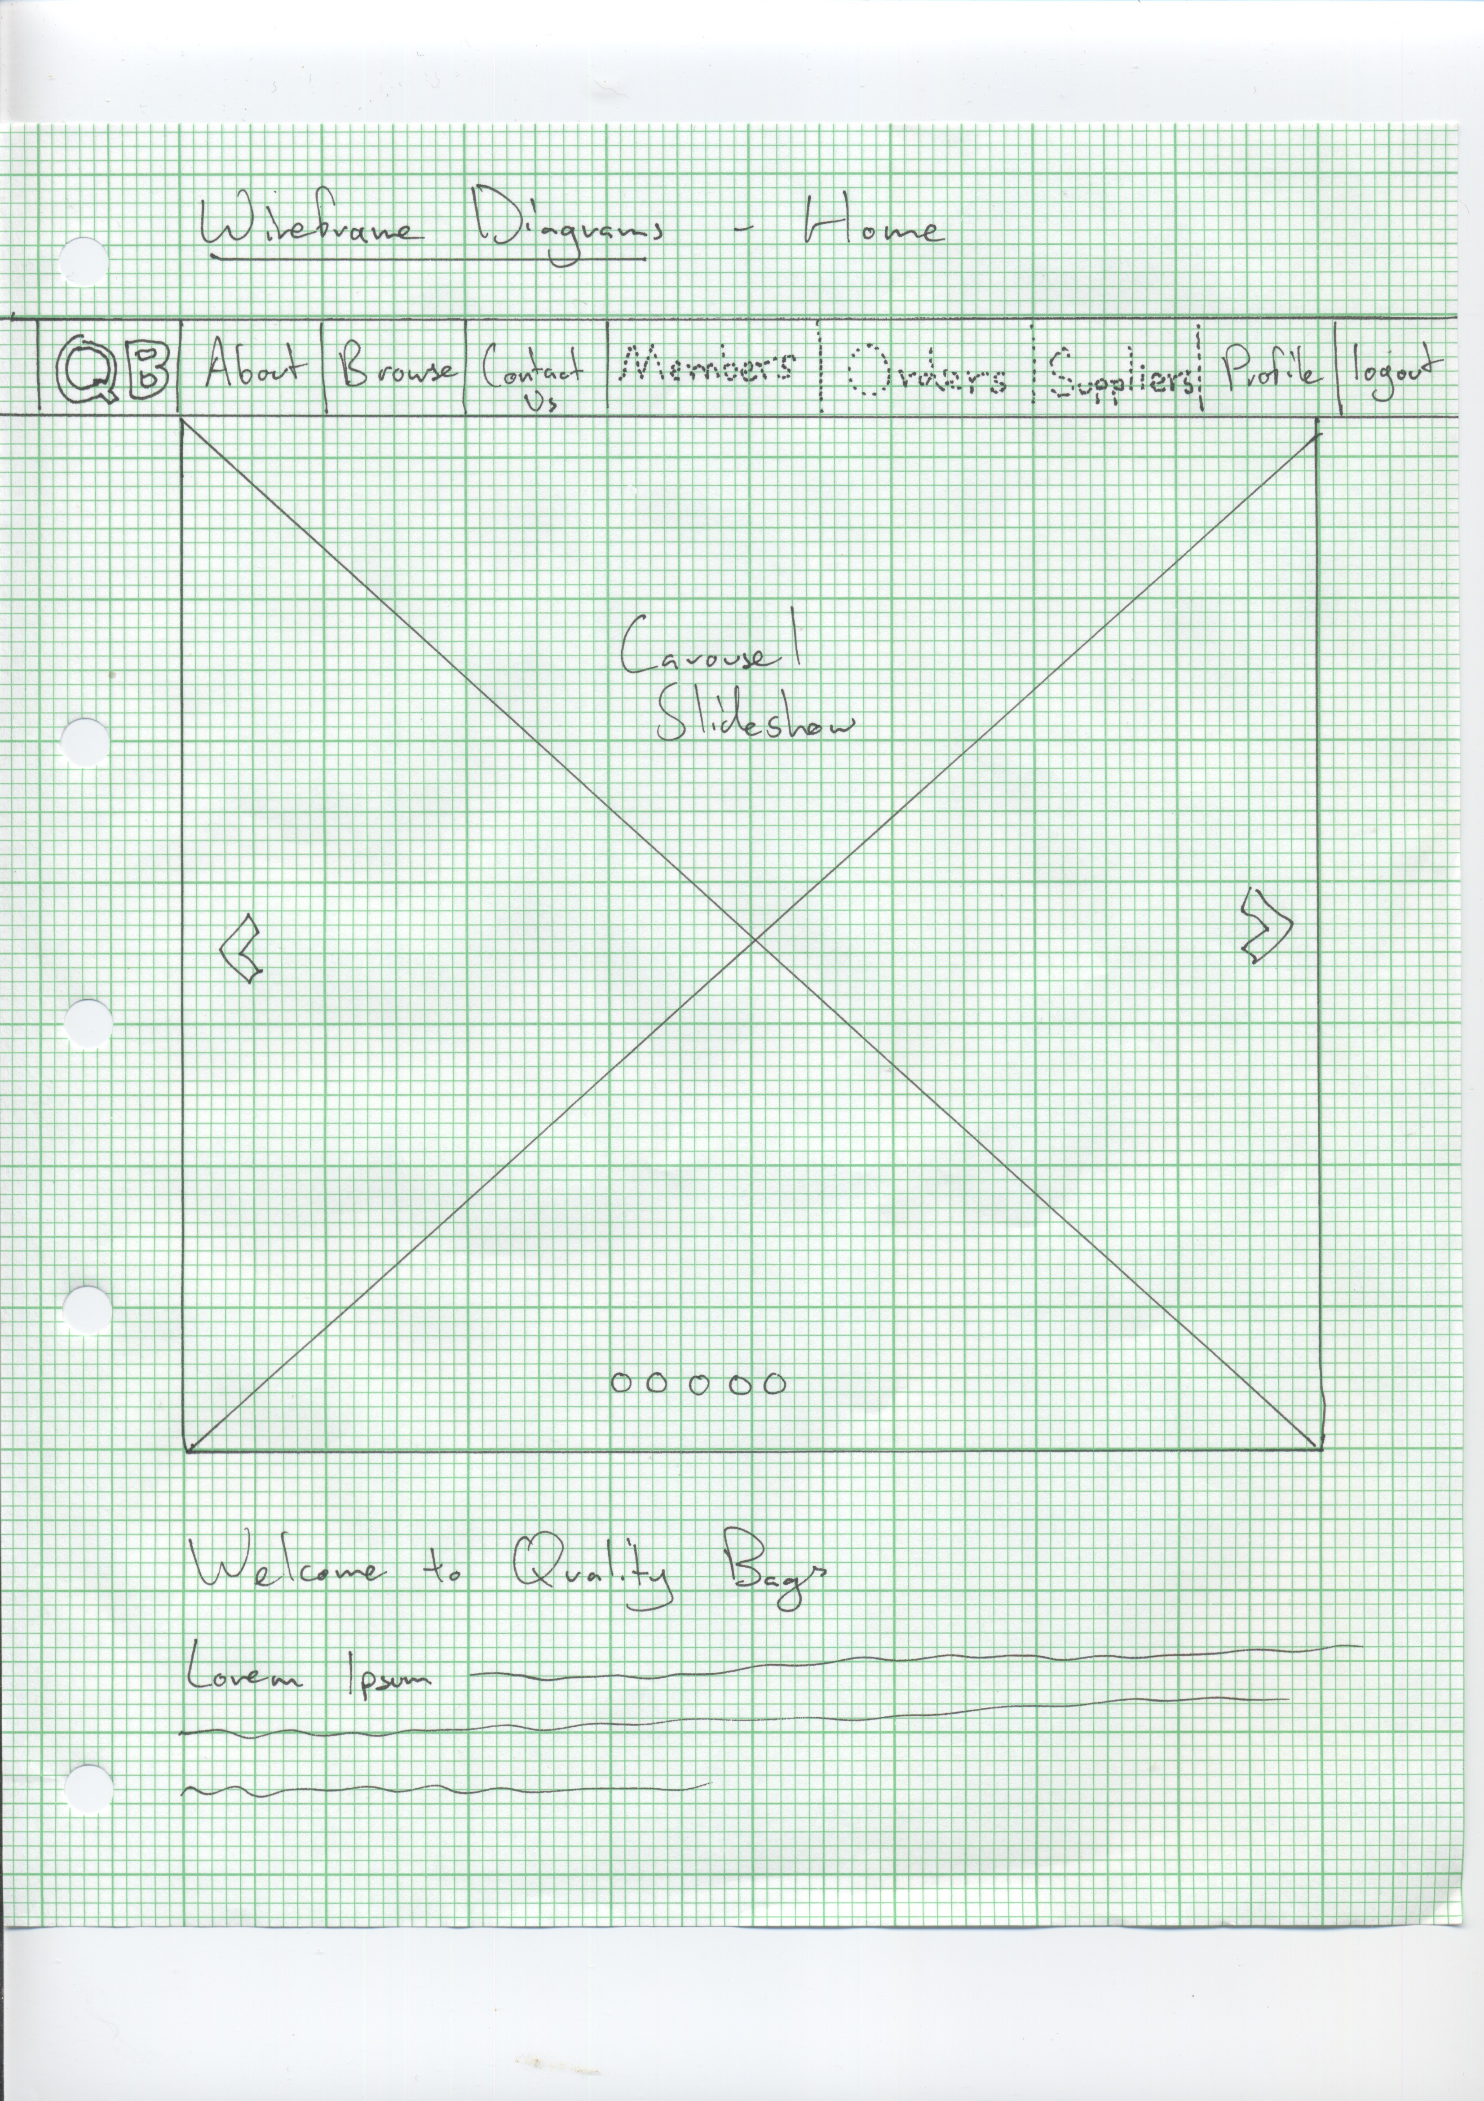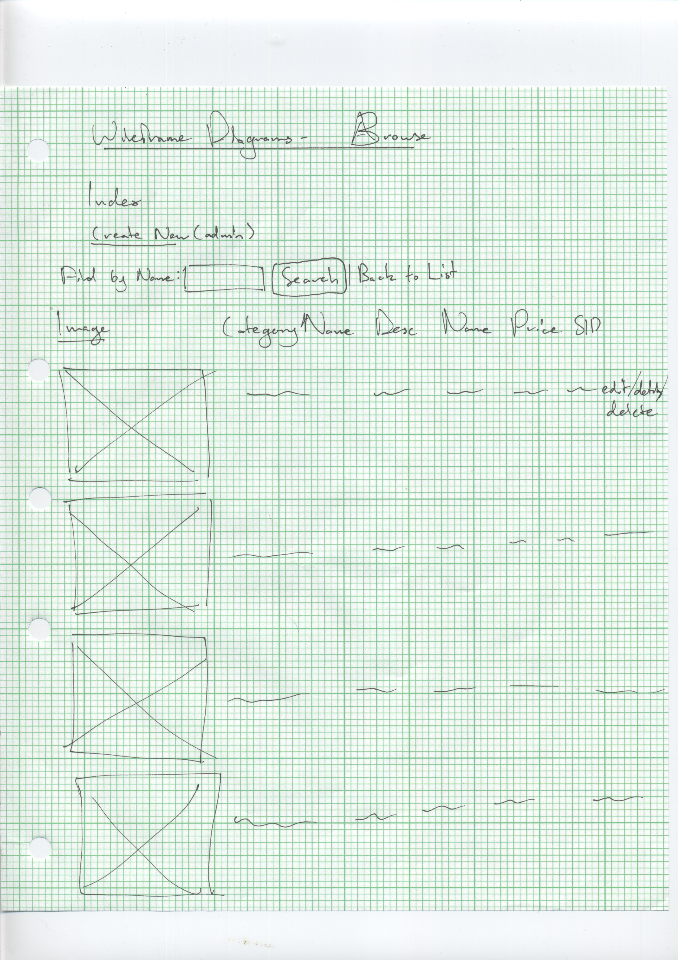

Database Design

(No ERD available due to Visual Studio issues)

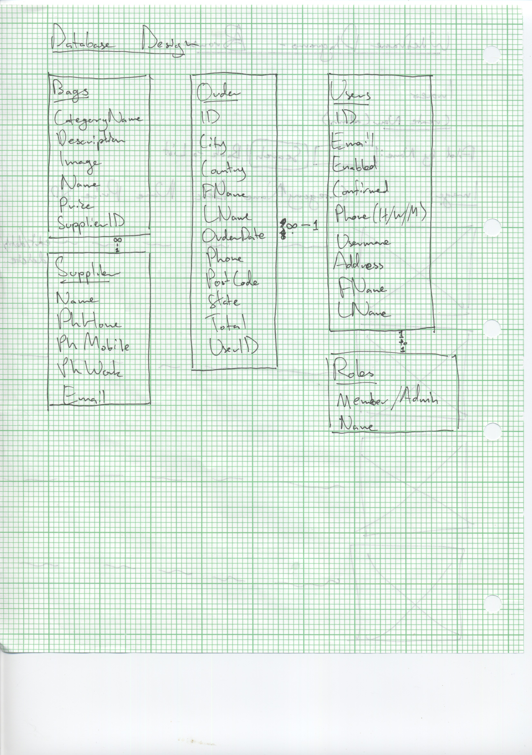

System Design Rationale

Server side:ASP.net EF Core with MVC framework used. Bags, Suppliers, Orders, Users, and User Roles were the main database tables used to implement the site architecture. Form validation and other forms of data validation used to ensure data validity and integrity. Admin/member roles implemented to ensure security and comfort of use to client side.

Client side:

Search tools, sorting, etc. used to give users a better sense of the products, ease of use, etc.

Test Data

|  |  |  |
| --- | --- | --- |
| Data Entered | Data Expected | Data Returned |
| Open Site | All assets in right place, no errors or irregular formatting | All assets in right place, no errors or irregular formatting |
| Click on image logo in corner | navigate to home page | navigate to home page |
| Click on about link in navbar | navigate to about page | navigate to about page |
| Click on contact us link in navbar | navigate to contact us page, contact us displays mailtos, relevant information, embedded google maps | navigate to contact us page, contact us displays mailtos, relevant information, embedded google maps |
| Click on register link | navigate to register page | navigate to register page |
| form data not filled out, register button pressed | disallowed due to form validation | disallowed due to form validation |
| valid data filled in, register button pressed | email validation sent and recieved | email validation sent and received |
| Validation URL clicked | validated and account created + enabled | validated and account created + enabled |
| Log in button clicked | navigate to login page | navigate to login page |
| invalid data entered to login page | disallowed due to form validation | disallowed due to form validation |
| valid data entered to login page | logged in as member | logged in as member |
| logged in as member | admin fields (members, orders, suppliers) not displayed on navbar | admin fields (members, orders, suppliers) not displayed on navbar |
| logged in as admin | admin fields (members, orders, suppliers) displayed on navbar | admin fields (members, orders, suppliers) displayed on navbar |
| browse button clicked | navigate to browse page, all features loading without issue | navigate to browse page, all features loading without issue |
| column names clicked | sorted according to column selected | sorted according to column selected |
| search data entered | respective item filtered to be the only displayed item on page | respective item filtered to be the only displayed item on page |
| Back to list button clicked | list refreshed | list refreshed |
| create new button clicked as admin | navigate to create page | navigate to create page |
| data entered, attempt to create bag entry, file chosen using file chooser | bag created and added to list | unhandled exception |
| data entered, create back without file chooser | bag created and added to list | bag created and added to list with broken image |
| edit data and save | entry updated | entry deleted |
| details button pressed | navigate to details of item | navigate to details of item |
| delete button pressed | entry deleted | entry deleted |
| disable member as admin | member no longer able to log in | member no longer able to log in |
| order placed using shopping cart | available in admin and able to be deleted | available in admin and able to be deleted |
| supplier link clicked as admin | navigate to supplier, valid info shown | navigate to supplier, valid info shown |
| CRUD used | functions work | unable to create, but other functions work |